
LA GRANDEE INTERNATIONAL COLLEGE
Simalchaur, Pokhara Nepal
A Project Proposal
On
“Quiz Game”

Submitted to:
Bachelor of Computer Application(BCA) Program
In partial fulfilment of the requirements for the degree of BCA under
Pokhara University
Submitted by:
Name: | Course | Semester | P.U. Registration Number
Sushant Adhikari | BCA | 2nd | 2025-1-53-0350
Miraj Puri | BCA | 2nd | 2025-1-53-0333
Prashant Tripathi | BCA | 2nd | 2025-1-53-0340
Date:13/05/2026
TABLE OF CONTENT
1. Introduction 1
2. Aim and scope 3
2.1 Aim 3
2.2 Scope 3
3. Objective 4
4. Study of Previous System 5
5. Current Problem and Proposed Solution 6
5.1 Current Problem 6
6. Detail Timeline 8
7. Design 9
7.1 Use case 9
7.2 Gantt Chart 10
8. Conclusion 11
9. References 12

LIST OF FIGURES
Figure 2:Use Case 9
Figure 3: Gantt Chart 10

Introduction
Quiz game System is an interactive application designed to prove a platform where user can directly participate in knowledge-based challenge and store their performance records. The main purpose of this project is to provide a customer with an alternative and convenient manner to buy movie tickets as per their needs. In the existing system there are several drawbacks. So, to sort out all the existing problems this project was chosen because it provides customer with an alternative and convenient manner to buy movie tickets as per their needs. This system helps to generate the quiz records to add and update them instantly. A paper-based or traditional quiz system will be changed into computerized system which will be more helpful and reliable.

This system helps to minimize the number of manual moderators required and to increase the efficiency of the overall evaluation process. Currently, a moderator cannot handle multiple participants or calculate scores at the same time if he/she is working manually. Hence, in order to reduce this problem a system is to be developed or required as per the today’s world scenario. So, for that we developed the system called Quiz Game System.

For our project, we divided work between us from the beginning. Documentation and coding was divided between all of us. Mainly, Gantt chart was sketched and requirement traceability matrix was done by Miraj Puri. Similarly, flowchart was graphically designed by Sushant Adhikari. Prashant Tripathi designed DFD. Research about project related information and testing platform and was handled by Prashant Tripathi and Miraj Puri. However, each member contributed to the coding and testing of each module and provided their valuable inputs to improve the system.

While doing research we knew that there were many difficulties regarding collection of question data, multiple user session, data was inaccurate, and adaptation in system according to different difficulty level was difficult while changing. By keeping we difficulties this system and we were successful to minimize these difficulties using C.

Going digitally is one of the great ideas in this time period because each and every thing has been digitalized and many of the work pressures will be overcome, work will be much faster and we will be able to find each and every thing in much more efficient way. We will be able to deliver a better experience for our user. Analyzing of data will be much more easier, so going digitally is best method.

Existing system are manual so it is low and also there is high chance of data damage due to external cause, finding of customers details in need was more time consuming. For this environment we developed Quiz Game System.

Aim and scope
The Aim and Scope section defines the primary goals and the boundaries of the Quiz Game System project.

2.1 Aim
The primary aim of this project is to develop a robust, computerized application using the C programming language to replace outdated manual quiz methods. By transitioning to a digital format, the project seeks to achieve the following:
Automation of Evaluation: To create a system that calculates scores instantly and accurately, removing the possibility of human error inherent in manual grading.
Efficiency and Speed: To provide a platform where questions are delivered and results are processed significantly faster than traditional paper-based methods.
Data Security and Integrity: To ensure that quiz data and user records are stored securely, minimizing the high risk of data damage or loss associated with physical files.

2.2 Scope
The scope outlines the specific functionalities and limitations of the system developed by the team:
User Management: The system is designed to collect player names and store their performance records for future reference.
Content Organization: It includes a structured question bank with multiple categories and difficulty levels that can be updated or modified as needed.
Interactive Interface: The project focuses on a user-friendly console interface developed in C that allows for seamless navigation through instructions and quiz modules.
Real-Time Reporting: The scope covers the generation of a final user summary or "report card" at the end of each session to provide immediate performance feedback.
Target Environment: While highly efficient, the current scope is focused on a localized environment (standalone system) rather than a wide-area network or web-based platform

Objective
The section is pivotal as the entire project development is centered around it. The following objectives have been clearly defined based on what we were able to achieve during the project completion. Each objective is designed to be SMART (Specific, Measurable, Achievable, Realistic, and Time-bound) and focuses on the completed tasks of the Quiz Game System.
- TO develop a user-friendly interface using C that allows players to navigate through different quiz categories seamlessly.
- TO implement a robust scoring algorithm that calculates and displays results immediately after the completion of a quiz session.
- TO organize a centralized database for storing a wide range of questions and multiple-choice answers across various difficulty levels.
- TO evaluate user inputs in real-time to provide instant feedback on whether the selected answer is correct or incorrect.
- TO integrate a timer functionality for each question to enhance the challenge and ensure the game remains engaging and time-bound.
- TO ensure data integrity by preventing unauthorized access to the answer keys within the system’s source code.
- TO illustrate the player's final performance through a comprehensive summary report generated at the end of every game.

Study of Previous System
The study of the previous system involves a detailed analysis of the traditional methods used for conducting quizzes before the implementation of a digital solution. Understanding these limitations was essential for developing a more reliable, computerized alternative using C programming.
The following points highlight the characteristics and drawbacks of the manual systems:
Manual and Paper-Based Methods: Historically, quiz environments relied on physical question papers and handwritten answer sheets, which were difficult to manage at scale.
Time-Consuming Retrieval: Finding specific participant details or historical scores in physical files was a slow and inefficient process.
Grading Inefficiency: Manual grading by moderators was slow and prone to human error, making it difficult to handle multiple participants simultaneously.
Data Vulnerability: There was a high risk of permanent data loss or damage due to external causes like physical wear, misplacement, or environmental factors.
Physical Storage Constraints: Previous systems required significant physical space to organize and store question banks and years of historical results.
Lack of Instant Feedback: Participants had to wait for manual evaluation and tallying, as traditional systems could not provide real-time results or performance analysis.
Dependence on Individuals: The system was heavily dependent on the presence and accuracy of specific individuals to manage data and interpret results, often leading to miscommunication.
By identifying these inefficiencies such as high access time, lack of security, and zero technology adaptation the team was able to define the necessary features for the proposed Quiz Game System. (Balagurusamy, 2019) (Pressman, 2014)

Current Problem and Proposed Solution
Based on the analysis of manual methods and the requirements for the new system, this section outlines the specific challenges faced and how the Quiz Game System aims to solve them.

Current Problem
The existing traditional or paper-based systems present several significant drawbacks that hinder efficiency and accuracy:
Manual Data Management: Recording quiz questions and participant scores by hand often leads to misplaced or inaccurate data.
Inefficiency and Time Constraints: Manual grading is a slow process that makes it difficult for a moderator to handle multiple participants simultaneously.
Data Vulnerability: There is a high risk of physical damage to records from external causes, leading to permanent loss of information.
Security Risks: Physical answer keys are vulnerable to unauthorized access or being leaked.
Limited Storage and Access: Storing years of historical quiz data requires significant physical space and makes retrieving specific user details time-consuming.
Lack of Feedback: Traditional methods do not provide real-time results, forcing participants to wait for manual evaluation.
  - Proposed Solution
To overcome these difficulties, we have developed a computerized Quiz Game System using C that offers a more reliable and modern approach. The proposed solutions include:
Automated Scoring: The system utilizes logic-driven algorithms to calculate and display results immediately after a quiz is completed.
Secure Digital Storage: By going digital, the system ensures that question banks and user records are stored safely, reducing the risk of damage or loss.
Enhanced Efficiency: Computerization allows for much faster work, overcoming the "work pressures" and time limitations of manual systems.
User-Friendly Interface: The application provides a convenient console-based platform for users to engage with different quiz categories seamlessly.
Data Accuracy: The digital format makes analyzing performance data much easier and ensures that scoring remains consistent and error-free.
Centralized Database: All information is stored in an organized digital format, allowing for quick access to user records and historical scores

Detail Timeline
The project timeline outlines the systematic approach taken by the team Prashant Tripathi, Sushant Adhikari and Miraj Puri to transition the quiz system from a manual process to a functional C application. This schedule ensures that all high-level requirements are met within the allocated period.

Phase Duration Activities
- Phase 1: Research & Proposal Week 1 Problem identification of previous manual systems, defining aim and scope, and drafting the initial proposal.
- Phase 2: System Design Week 2 Creating logic flows, including ER diagrams to define data relationships and DFDs to map data movement.
- Phase 3: Development Week 3 - 4 Coding core functionalities in C, such as the scoring engine, file handling for the question bank, and the user interface.
- Phase 4: Testing & Debugging Week 5 Rigorous testing of the scoring logic and fixing errors related to data integrity and session management.
- Phase 5: Documentation Week 6 Compiling the final project report, user manuals, and references.

Design

Use case
The Use Case diagram serves as a behavioral model that describes the functionality of the Quiz Game System from the perspective of its users. It identifies the interactions between the Actor (the person using the system) and the various Use Cases (the specific services provided)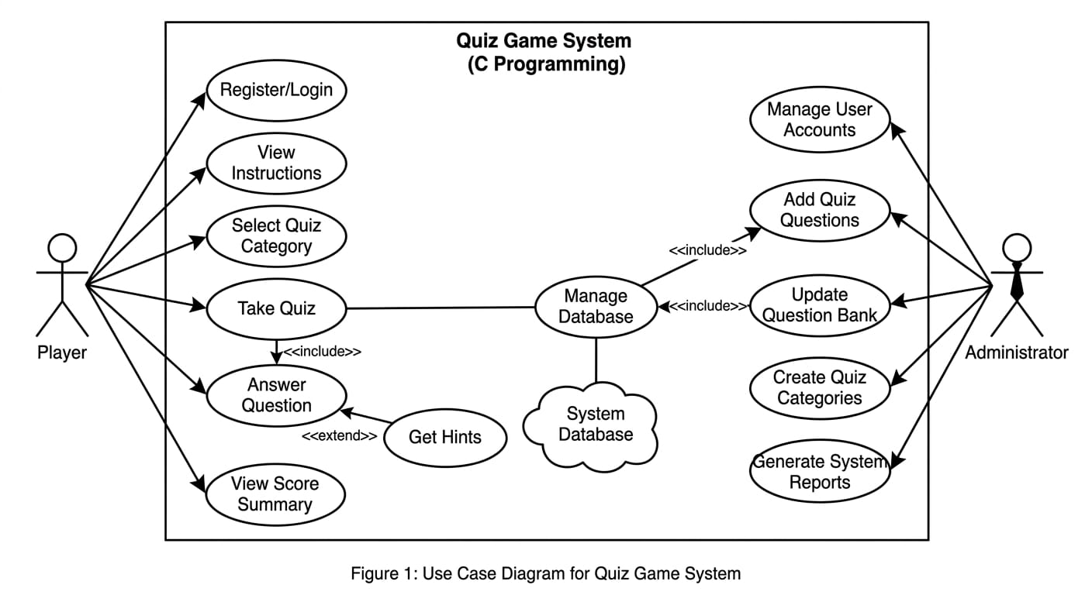
Figure 2:Use Case

Gantt Chart
A Gantt Chart was prepared to schedule and track the progress of each phase, ensuring the project is completed within the given academic

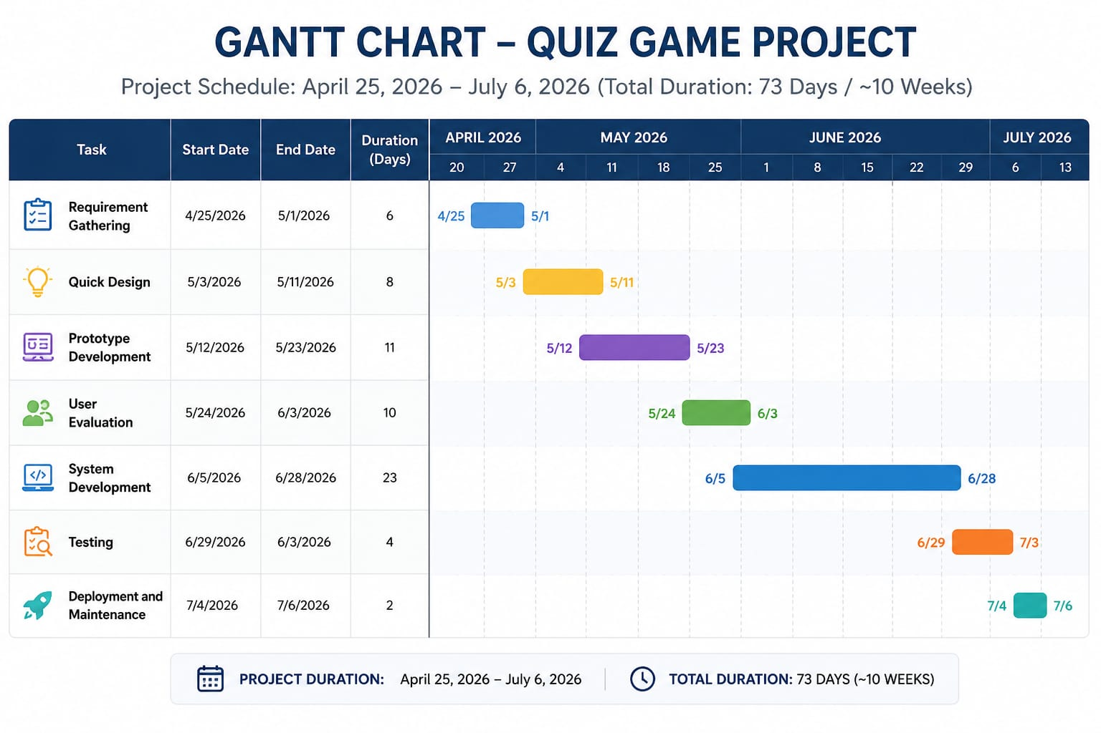
Figure 3: Gantt Chart

Conclusion
The development of the Quiz Game System in C demonstrates that transitioning from manual, paper-based administration to a computerized format is the most effective method for modern assessment needs. By addressing the core issues of traditional systems—such as high data vulnerability, slow grading processes, and physical storage constraints—the team has delivered a platform that is both efficient and reliable.
The final system successfully achieved its primary objectives:
- Automation: It eliminates the "work pressures" and human errors associated with manual evaluation by providing instantaneous scoring and feedback.
- Data Organization: Through structured digital storage, the project minimized the risk of data loss and made the retrieval of user performance records significantly faster.
- User Experience: The interactive console-based interface provides a secure and engaging environment for participants to test their knowledge across various categories.
- Despite facing initial challenges regarding data collection and session management, the collaborative efforts of the team members ensured the delivery of a robust system. This project serves as a clear example of how C programming can be utilized to create organized, fast, and secure software solutions that solve real-world administrative problems.

References
Balagurusamy. (2019). Programming in ANSI C. McGraw HIll.
Pressman, R. S. (2014). Softwer Engineering :A Practitioner's Approach. McGraw Hill.

​
​

